**Integrative Programming and Tech 2**

Jandel L. Escalera

BSIT - 4F1

**Part 1: Creating HTML CSS File**

Create a new HTML File

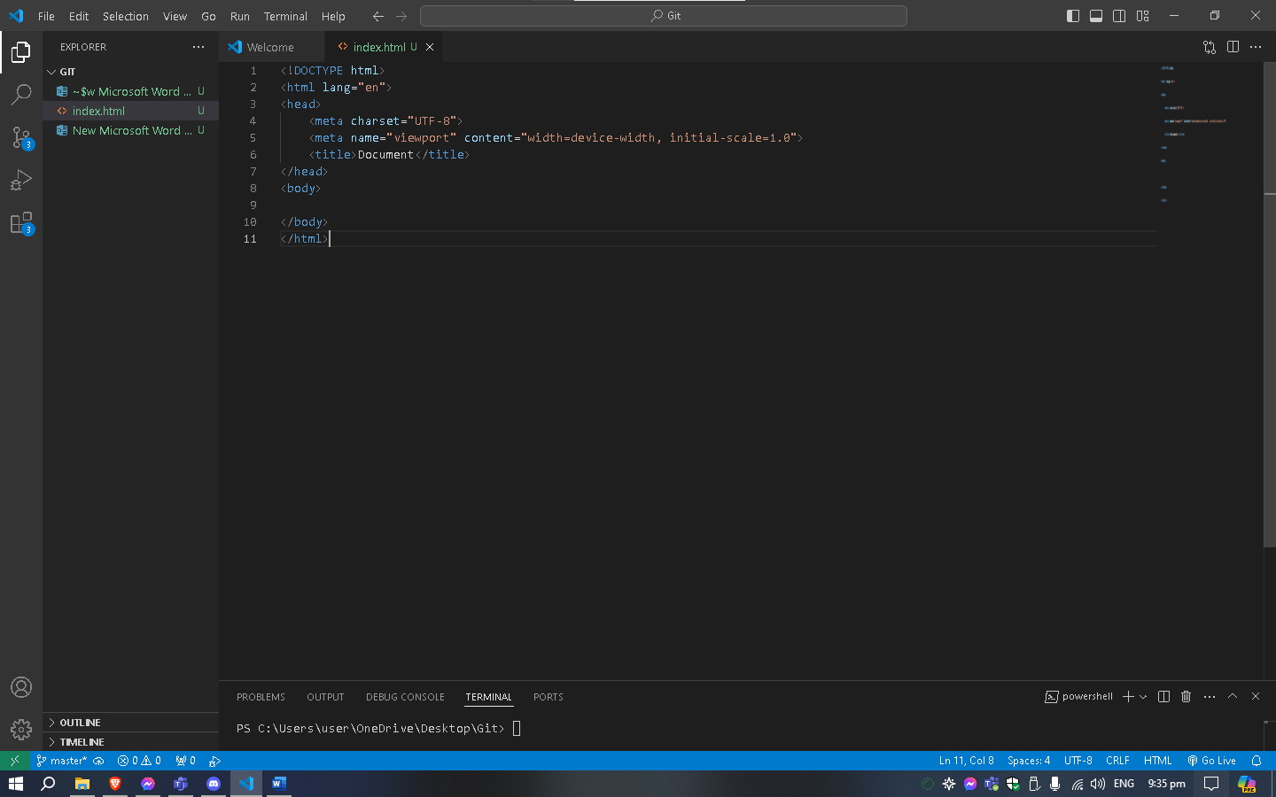

Add basic CSS styling to your HTML (inline or external).

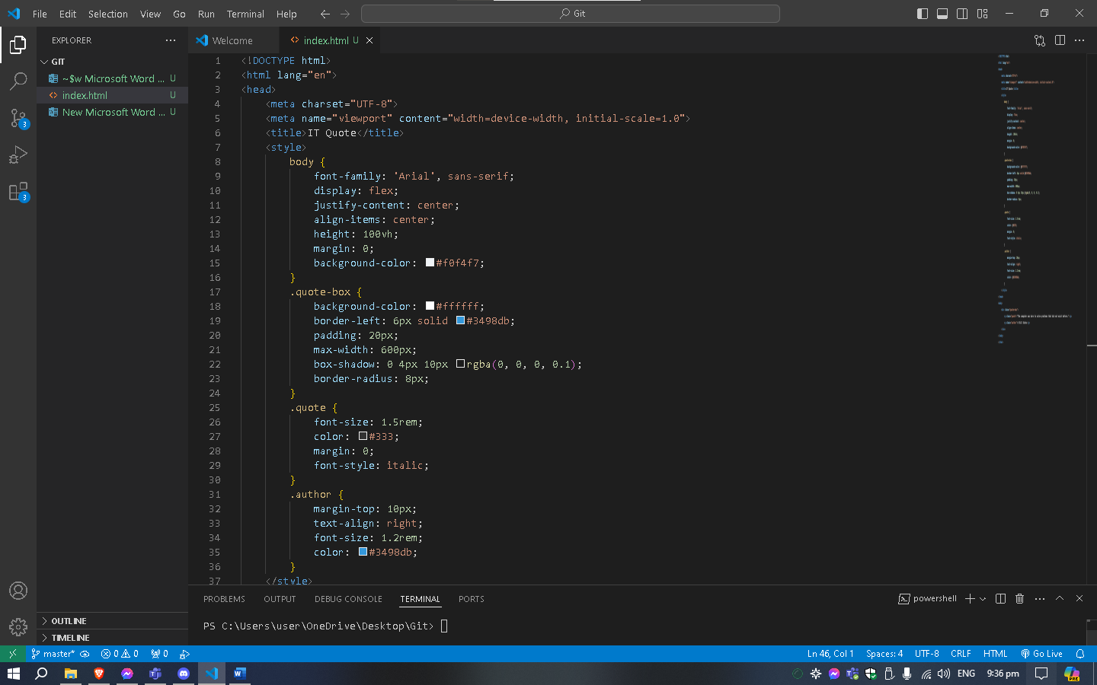

Testing: Open the HTML file in a web browser to ensure it displays correctly

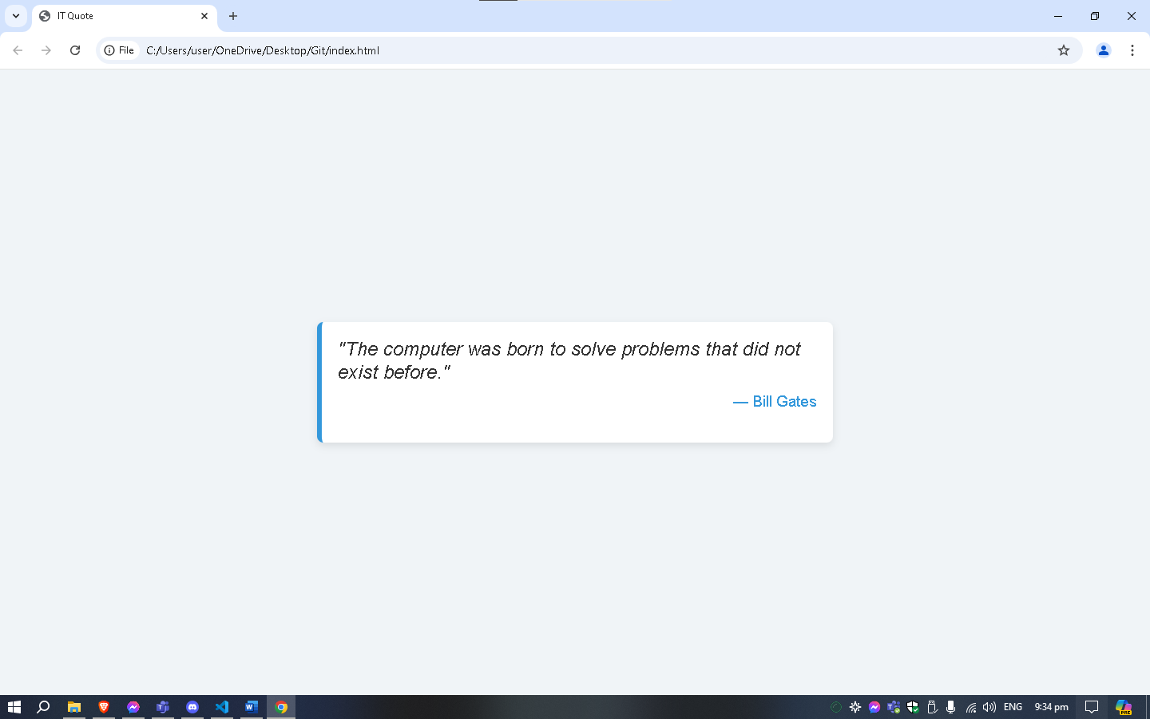

**Part 2: Managing Version Control with Git**

Initializing a Git Repository